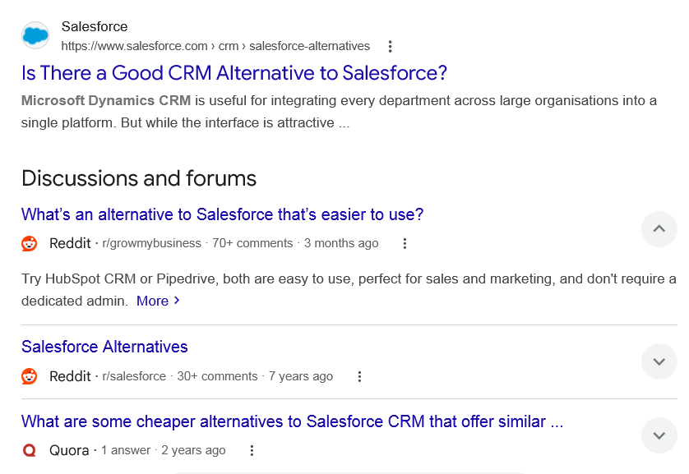
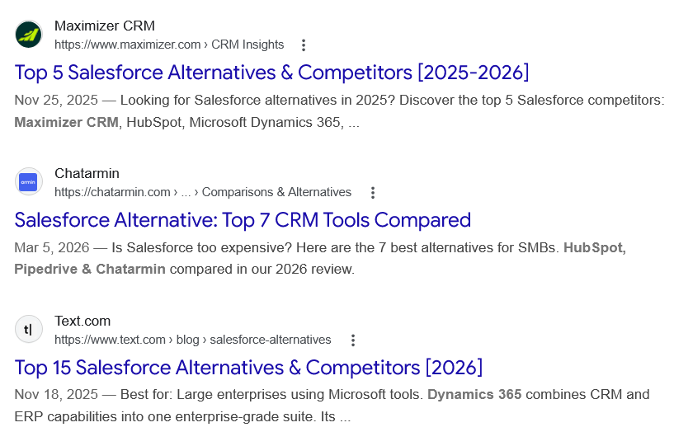
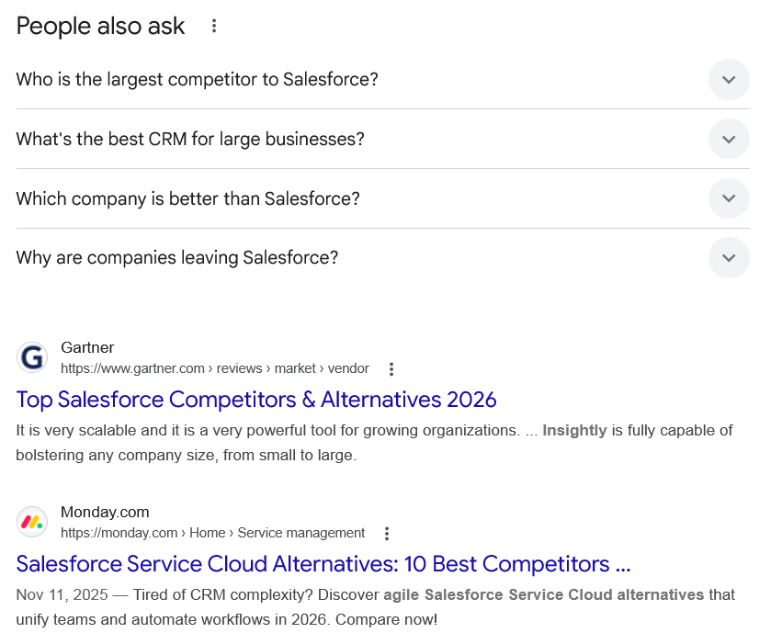
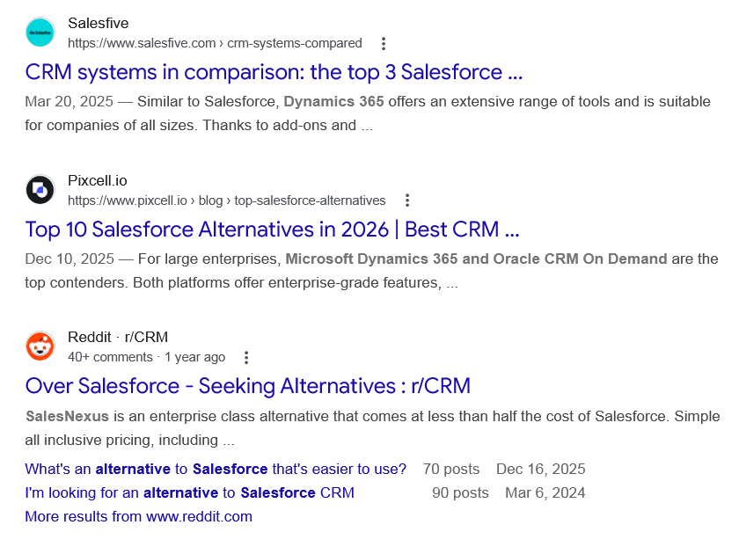
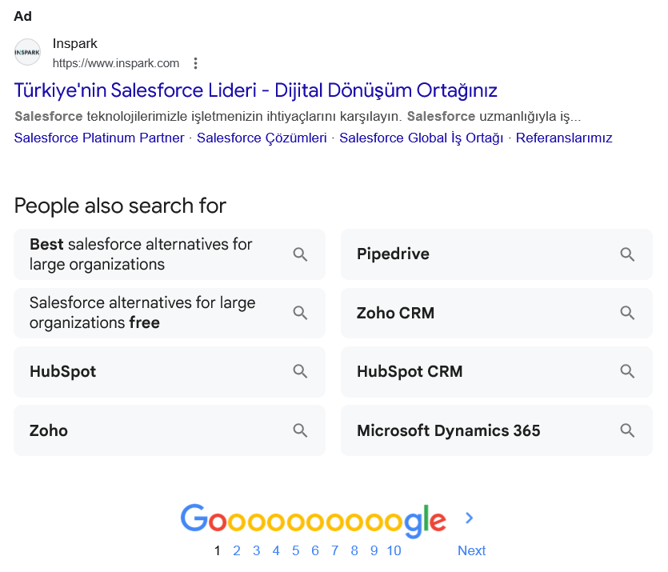

Web results

Is There a Good CRM Alternative to Salesforce?

Salesforce
https://www.salesforce.com › crm › salesforce-alternatives

Salesforce
https://www.salesforce.com › crm › salesforce-alternatives
Microsoft Dynamics CRM is useful for integrating every department across large organisations into a single platform. But while the interface is attractive ...
Discussions and forums

What’s an alternative to Salesforce that’s easier to use?
Reddit ·
r/growmybusiness
· 70+ comments
· 3 months ago

What’s an alternative to Salesforce that’s easier to use?
Reddit ·
r/growmybusiness
· 70+ comments
· 3 months ago
Try HubSpot CRM or Pipedrive, both are easy to use, perfect for sales and marketing, and don't require a dedicated admin. More

Salesforce Alternatives
Reddit ·
r/salesforce
· 30+ comments
· 7 years ago

Salesforce Alternatives
Reddit ·
r/salesforce
· 30+ comments
· 7 years ago
Zoho works great if you have 8 employees and some technical people to hurdle some of the gaps. Zoho CRM has a tier that offers customizations ... More

What are some cheaper alternatives to Salesforce CRM that offer similar ...
Quora ·
1 answer
· 2 years ago

What are some cheaper alternatives to Salesforce CRM that offer similar ...
Quora ·
1 answer
· 2 years ago
1- SugarCRM. It's a powerful CRM that's being used by over 800,000 companies worldwide. · 2- Zoho CRM · 3- HubSpot CRM. More

See more

Web results

Top 5 Salesforce Alternatives & Competitors [2025-2026]

Maximizer CRM
https://www.maximizer.com › CRM Insights

Maximizer CRM
https://www.maximizer.com › CRM Insights
Nov 25, 2025 — Looking for Salesforce alternatives in 2025? Discover the top 5 Salesforce competitors: Maximizer CRM, HubSpot, Microsoft Dynamics 365, ...

Salesforce Alternative: Top 7 CRM Tools Compared

Chatarmin
https://chatarmin.com › ... › Comparisons & Alternatives

Chatarmin
https://chatarmin.com › ... › Comparisons & Alternatives
Mar 5, 2026 — Is Salesforce too expensive? Here are the 7 best alternatives for SMBs. HubSpot, Pipedrive & Chatarmin compared in our 2026 review.

Top 15 Salesforce Alternatives & Competitors [2026]

Text.com
https://www.text.com › blog › salesforce-alternatives

Text.com
https://www.text.com › blog › salesforce-alternatives
Nov 18, 2025 — Best for: Large enterprises using Microsoft tools. Dynamics 365 combines CRM and ERP capabilities into one enterprise-grade suite. Its ...
People also ask
Who is the largest competitor to Salesforce?
Top Salesforce Alternatives
- Microsoft.
- Oracle.
- SAP.
- Zoho.
- SugarCRM.
- HubSpot.
- Zendesk.
- Freshworks.

Top Salesforce Competitors & Alternatives 2026 - Gartner

Gartner
https://www.gartner.com › reviews › market › vendor

Gartner
https://www.gartner.com › reviews › market › vendor
What's the best CRM for large businesses?
10 of the most common CRMs we encounter, separated by use case.
- Salesforce. A purpose-built product for customer relationship management and an industry veteran. ...
- Microsoft Dynamics 365. ...
- Hubspot. ...
- SugarCRM. ...
- Zoho CRM. ...
- Less Annoying CRM (LACRM) ...
- Blackbaud Raiser's Edge NXT. ...
- Pipedrive.
More items...

What's the Best CRM for Your Business? Top 10 CRMs by Use ...

Database Consultants Australia
https://data.com.au › data-services › data-technology › b...

Database Consultants Australia
https://data.com.au › data-services › data-technology › b...
Which company is better than Salesforce?
The best Salesforce alternatives in 2026 are: Creatio, Zoho, HubSpot, Freshworks, Microsoft Dynamics, Vtiger, Oracle, SAP, Pegasystems, Zendesk, Insightly, and Monday.com.Jan 14, 2026

Top 12 Salesforce Alternatives and Competitors in 2026

Creatio
https://www.creatio.com › glossary › salesforce-alternati...

Creatio
https://www.creatio.com › glossary › salesforce-alternati...
Why are companies leaving Salesforce?
As businesses reevaluate their technology stacks in 2025 and beyond, many Salesforce customers are finding themselves burdened with rising costs, limited flexibility, and underutilized features.Jul 28, 2025

Why Leave Salesforce for Dynamics 365 CE? - CTP

Covenant Technology Partners
https://covenanttechnologypartners.com › 2025/07/28

Covenant Technology Partners
https://covenanttechnologypartners.com › 2025/07/28

Web results

Top Salesforce Competitors & Alternatives 2026

Gartner
https://www.gartner.com › reviews › market › vendor

Gartner
https://www.gartner.com › reviews › market › vendor
It is very scalable and it is a very powerful tool for growing organizations. ... Insightly is fully capable of bolstering any company size, from small to large.

Salesforce Service Cloud Alternatives: 10 Best Competitors ...

Monday.com
https://monday.com › Home › Service management

Monday.com
https://monday.com › Home › Service management
Nov 11, 2025 — Tired of CRM complexity? Discover agile Salesforce Service Cloud alternatives that unify teams and automate workflows in 2026. Compare now!

CRM systems in comparison: the top 3 Salesforce ...

Salesfive
https://www.salesfive.com › crm-systems-compared

Salesfive
https://www.salesfive.com › crm-systems-compared
Mar 20, 2025 — Similar to Salesforce, Dynamics 365 offers an extensive range of tools and is suitable for companies of all sizes. Thanks to add-ons and ...

Top 10 Salesforce Alternatives in 2026 | Best CRM ...

Pixcell.io
https://www.pixcell.io › blog › top-salesforce-alternatives

Pixcell.io
https://www.pixcell.io › blog › top-salesforce-alternatives
Dec 10, 2025 — For large enterprises, Microsoft Dynamics 365 and Oracle CRM On Demand are the top contenders. Both platforms offer enterprise-grade features, ...

Over Salesforce - Seeking Alternatives : r/CRM

Reddit · r/CRM
40+ comments · 1 year ago

Reddit · r/CRM
40+ comments · 1 year ago
SalesNexus is an enterprise class alternative that comes at less than half the cost of Salesforce. Simple all inclusive pricing, including ...
What's an alternative to Salesforce that's easier to use?
70 posts
Dec 16, 2025
I'm looking for an alternative to Salesforce CRM
90 posts
Mar 6, 2024
More results from www.reddit.com
Ad

Türkiye'nin Salesforce Lideri - Dijital Dönüşüm Ortağınız

Inspark
https://www.inspark.com

Inspark
https://www.inspark.com

My Ad Centre
Salesforce teknolojilerimizle işletmenizin ihtiyaçlarını karşılayın. Salesforce uzmanlığıyla iş...
‎Salesforce Platinum Partner · ‎Salesforce Çözümleri · ‎Salesforce Global İş Ortağı · ‎Referanslarımız
People also search for

Best salesforce alternatives for large organizations

Salesforce alternatives for large organizations free

HubSpot

Zoho

Pipedrive

Zoho CRM

HubSpot CRM

Microsoft Dynamics 365

Page navigation
 | 1 | 2 | 3 | 4 | 5 | 6 | 7 | 8 | 9 | 10 | Next

